Waterfall Model Documents

Waterfall Project2 – Part -2/2 – 100 Marks - Pass 60 % Instructions to follow:
- Copy paste (either image, diagram or text) is not entertained. If done, the document will not be
evaluated.
- After submission of the answers of this exam, you should be prepared to attend viva and justify your answers in the exams. If in Viva, participant is NOT justifying the answers, Viva will be repeated until Candidates justify 60% correctness.
- Mentor calls are scheduled only if the participant have submitted their task at least for one time. (should apply their knowledge in this task first)
- For attempting the exams participant should be thorough on the topics using their references.
- Please format the document properly (Always have a question no., question and answer).
- Have a consistent format (Font name: Arial/ Calibri -Font size 12, Font Color: Black).
- Answers should be elaborated in detail (not as per the allotted marks).
- Please focus on learning and applying the knowledge as this knowledge will be helpful in contributing at your BA job.
- In the evaluation, students must answer all questions and should be able to justify at least 60% content and correctness of each answer.

Part 2/2 Evaluation
Document 6- Please prepare a use case diagram, activity diagram and a use case specification document.
Document 7- Screens and pages
Document 8- Tools-Visio and Axure
Document 9- BA experience
My experience as BA in following phases:
- Requirement gathering:
- Requirement Analysis:
- Design:
- Development:
- Testing:
- Deployment:

Document 6- Please prepare a use case diagram, activity diagram and a use case specification document.

USE CASE:

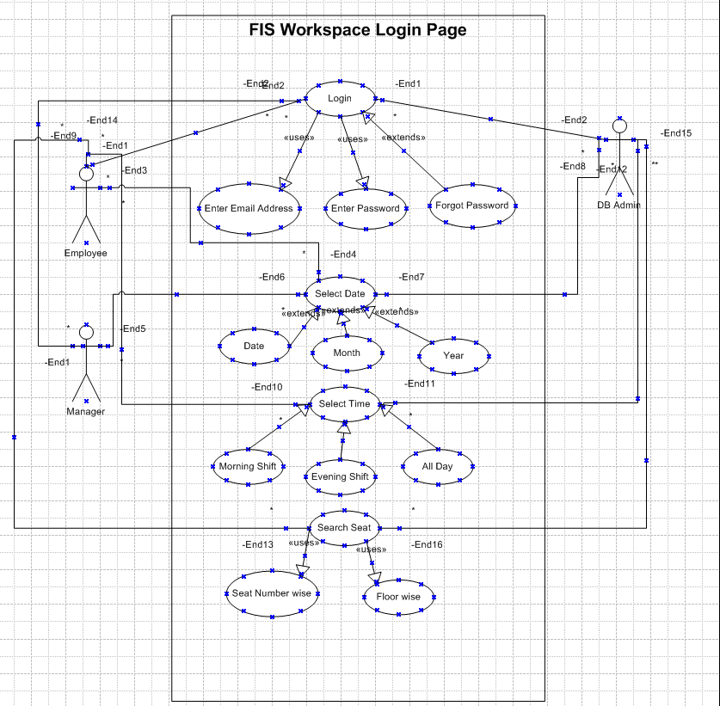

Activity Diagram:-

Registration Page : Login Page:

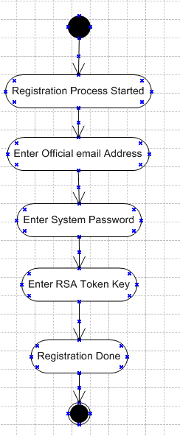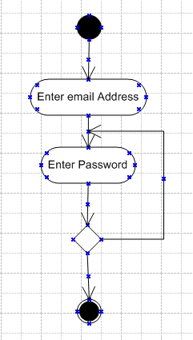

Select Date: Select Time:

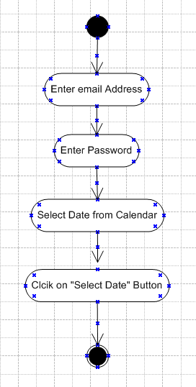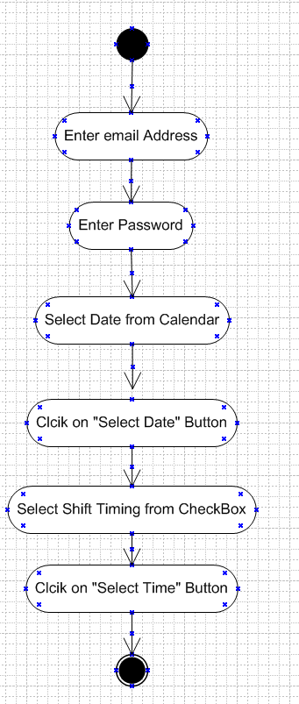

Select Seat Number: Select Seat Booking Confirmation:

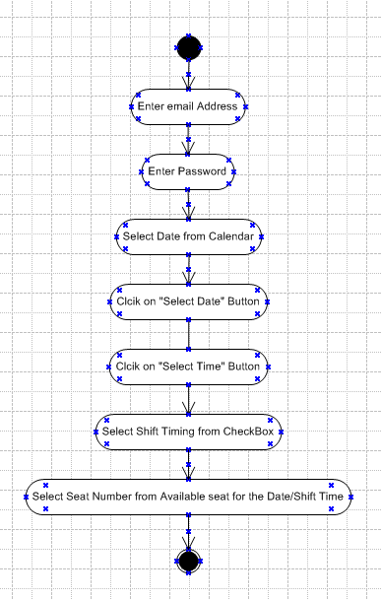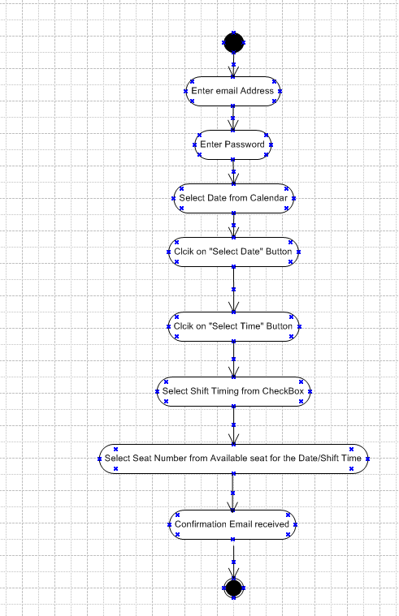

Seat can be search by Seat Number or Floor wise:
Seat Confirmation Done by Reporting Manager

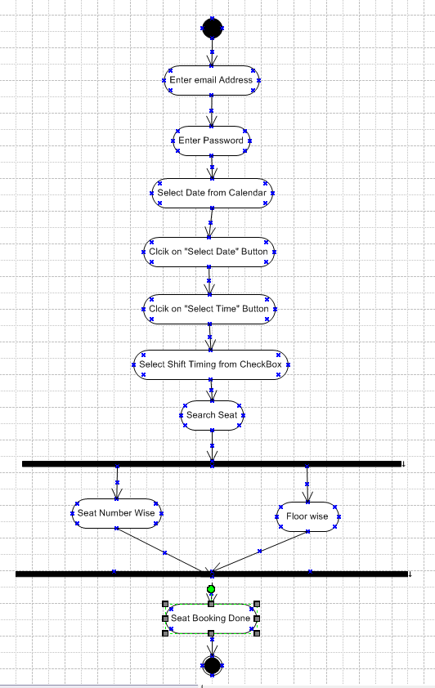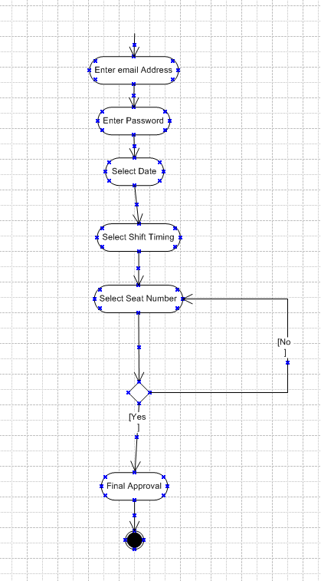
  - Use case Name: FIS Book Workspace Seat
  - Use case Description: An authenticated employee searches for an available desk or meeting room, selects date/time (single or recurring), requests any required approvals, confirms the booking, and optionally checks in on arrival. The system enforces quotas, prevents double bookings, synchronizes with calendars, updates occupancy analytics, and notifies stakeholders.
  - Actors Primary Actors Secondary actors :
Primary actors: Employee (requester); Manager (approver for special/group requests).
Secondary actors: Admin / Facilities, Scheduler Service, HRMS, Calendar Service (Outlook/Google), Notification Gateway (email/SMS), IoT/Occupancy Service (optional).
  - Basic Flow
- Employee authenticates via SSO.
- Employee opens Search Seats and filters by building/floor/date/time.
- System displays real-time availability and floor map.
- Employee selects seat/room, enters purpose, attendees, and recurrence (if any).
- System validates business rules (quota, no double booking, role restrictions).
- If validation passes and no approval required, system creates booking, sends confirmation, and syncs calendar.
- If check-in is required, employee checks in within the allowed window; system records attendance.
- Dashboards and occupancy analytics update; RTM/records updated if applicable.
  - ALTERNATE FLOW
A1 — Approval required: Booking exceeds quota or is a group/townhall request → system routes to Manager for approval → on approval proceed to step 6; on rejection notify employee and close request.
A2 — Recurring booking conflict: System suggests alternate slots or allows employee to submit exception request; exception follows approval flow.
A3 — Offline scheduler: Scheduler service unavailable → system queues request, informs user of delayed confirmation, retries when service restored.
  - Exceptional flows
E1 — Double booking at commit time: System rejects booking and suggests nearest available seats; logs incident.
E2 — SSO/authentication failure: User cannot proceed; system shows error and support contact.
E3 — HRMS data mismatch: Booking flagged for reconciliation; BA/Operations notified; booking held until resolved.
E4 — Calendar sync failure: Booking created but calendar invite not sent; system retries and alerts user if persistent.
  - Pre- Conditions
• Employee has valid SSO credentials and role mapping in HRMS.
• Seat inventory and floor maps are loaded and current.
• Scheduler, calendar, and notification services are reachable.

  - post-conditions
• Booking record persisted with unique Booking ID.
• Calendar event created (if enabled).
• Dashboards and occupancy metrics updated.
• Notifications sent to requester and approver (if applicable).
• Audit trail entry created.
  - Assumptions
• Business provides accurate floor maps and sample data.
• Users will follow check-in rules for occupancy accuracy.
• Network and SSO services are available during business hours.
• Approval SLAs are defined and respected.
  - Constraints
• Deployments limited to agreed maintenance windows.
• Performance target: booking confirmation ≤ 2 seconds under normal load.
• Sensitive data must be masked per GDPR/local rules.
• No direct DB changes without data-owner approval.
  - Dependencies
• HRMS for employee attributes and role mapping.
• Calendar services for invite sync.
• Scheduler and notification services.
• IoT occupancy feeds (optional) for verification.
• Facilities team for floor map and asset updates.
  - Inputs and Outputs
Input: Employee ID; building/floor; seat/room ID; date/time; recurrence rules; purpose; attendees; attachments (optional).
Output: Booking ID; confirmation message; calendar invite; updated occupancy metrics; audit log entry.
  - Business Rules
• No double booking for same seat/time.
• Manager approval required for group bookings > X seats or bookings outside normal hours.
• Check-in required within Y minutes of start or booking marked no-show.
• Reserved seats visible only to Admin/Managers.
• Sensitive fields masked for non-authorized roles.
• SLA: Manager must respond to approval requests within Z hours.
  - Miscellaneous Information
• Track effort and conversion metrics for legacy report migrations (if applicable).
• Maintain RTM linkage for bookings tied to tracked requirements.
• Log metrics: booking time, check-in compliance, no-show rate, average approval time.
• Suggested acceptance criteria: create booking end-to-end; calendar sync; check-in recorded; no double booking under concurrent load test.

Document 7- Screens and pages
Please follow the following steps to create the mock-ups
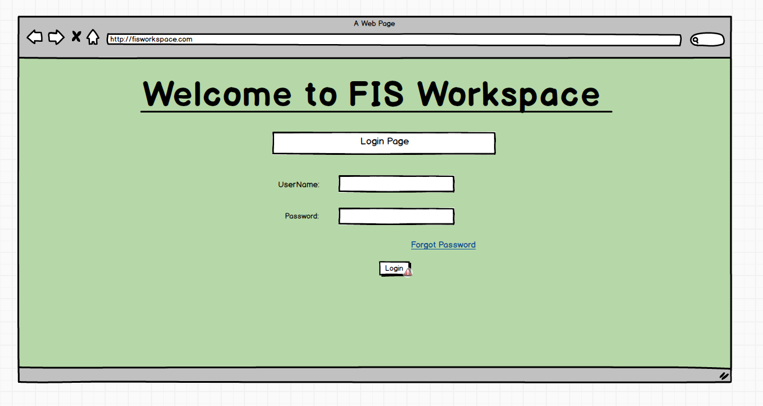

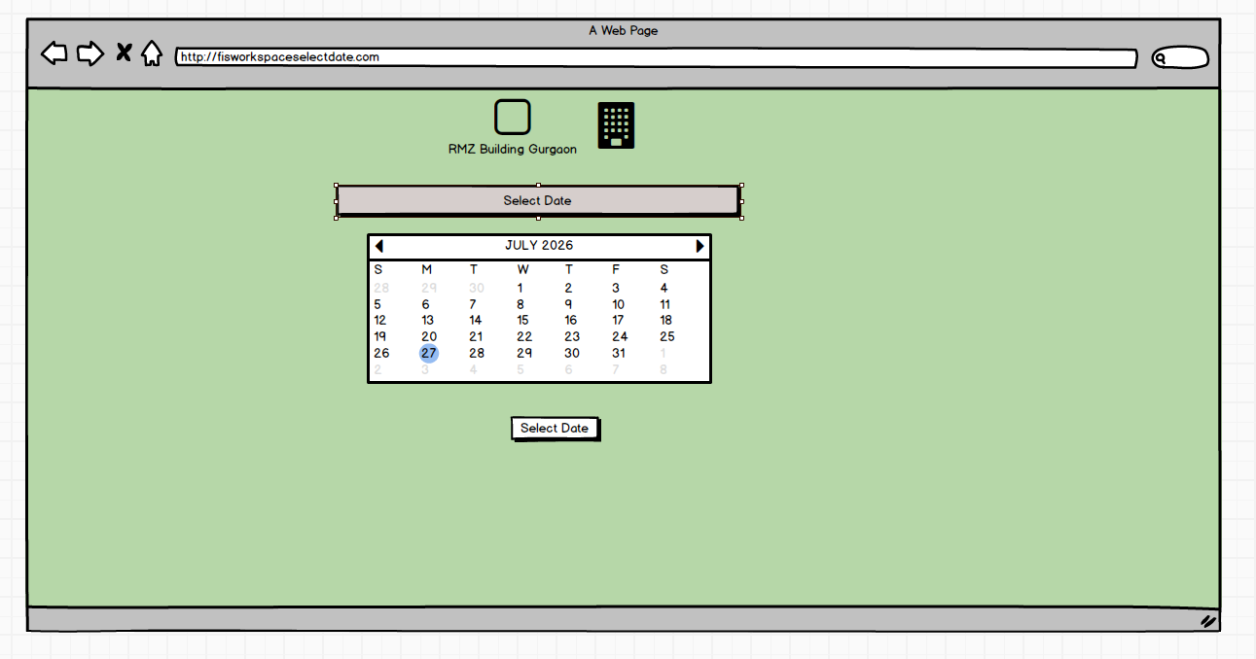

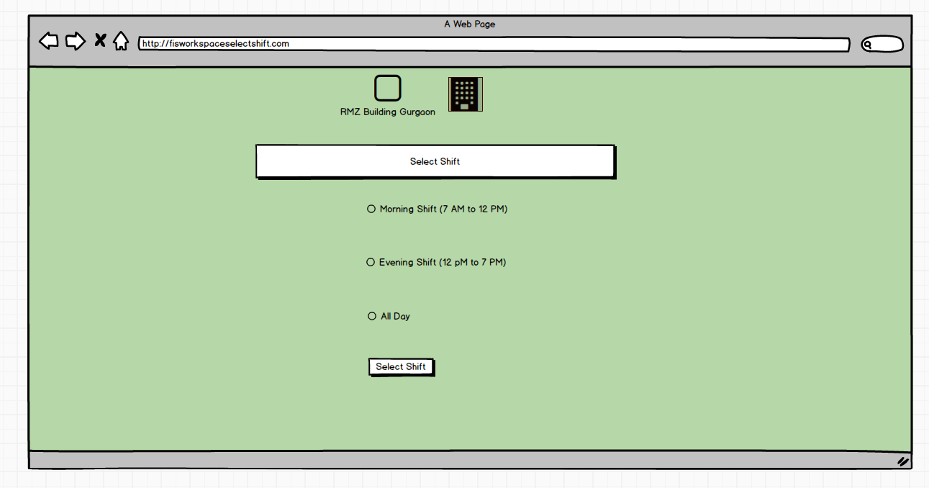

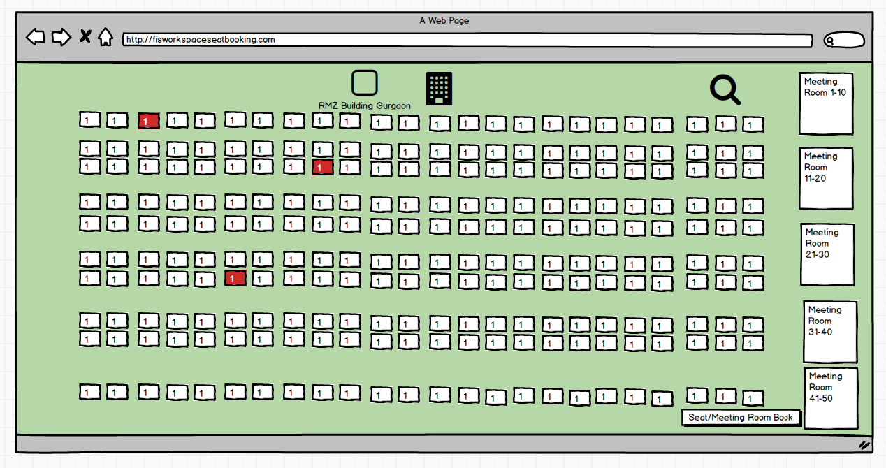
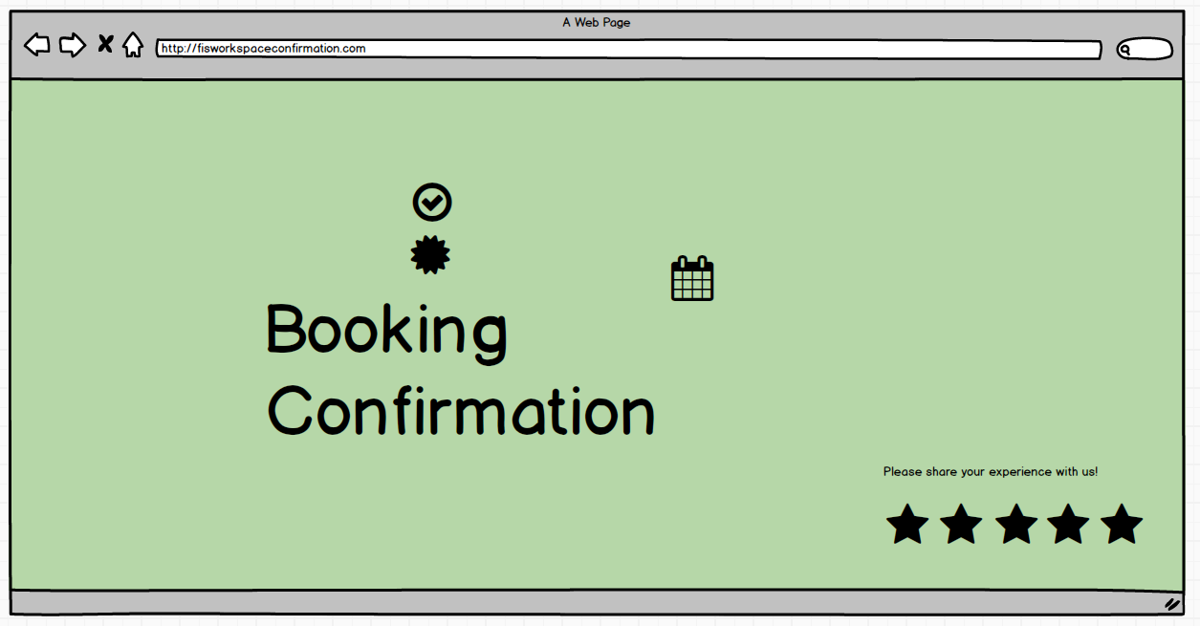

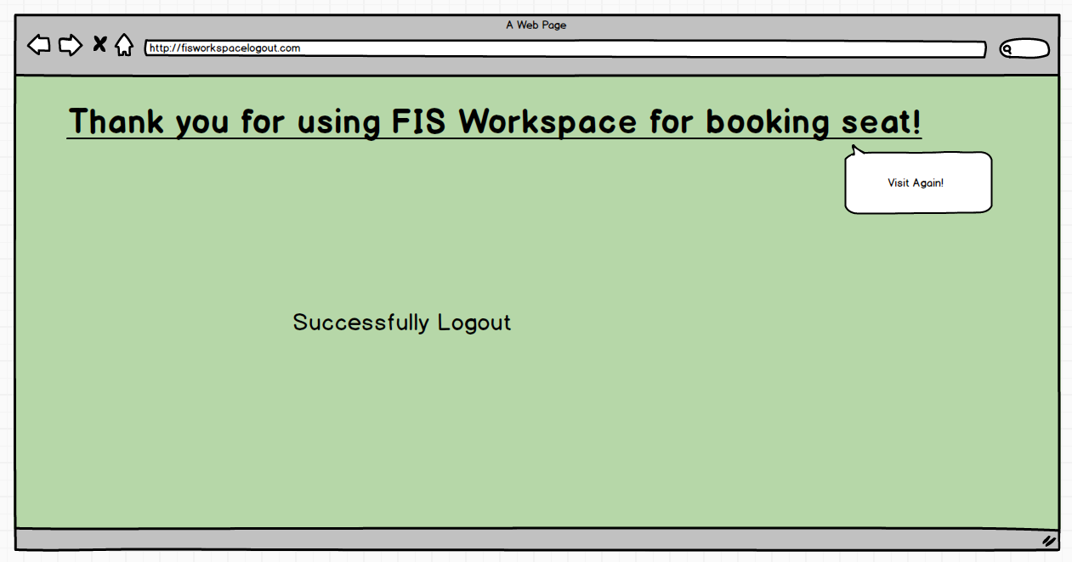

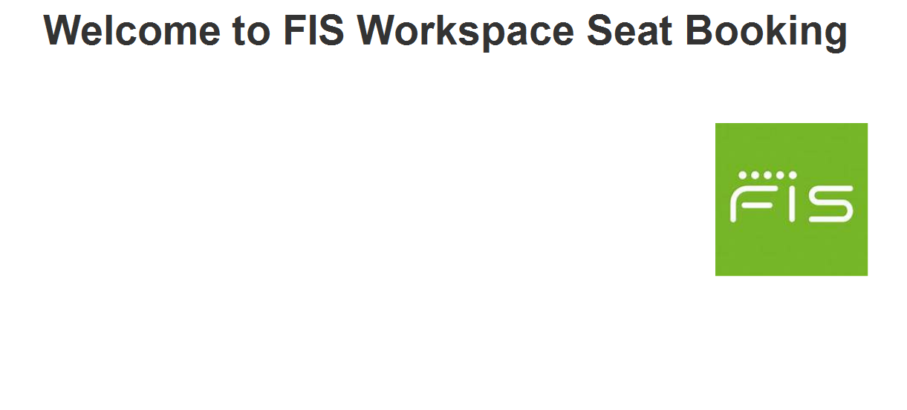

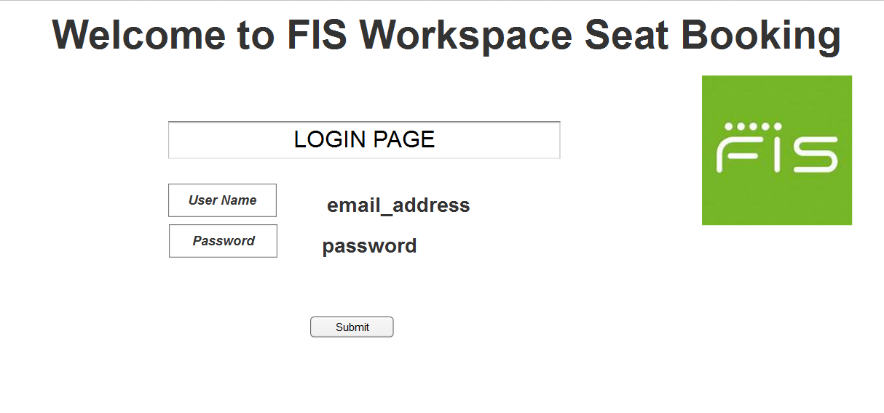

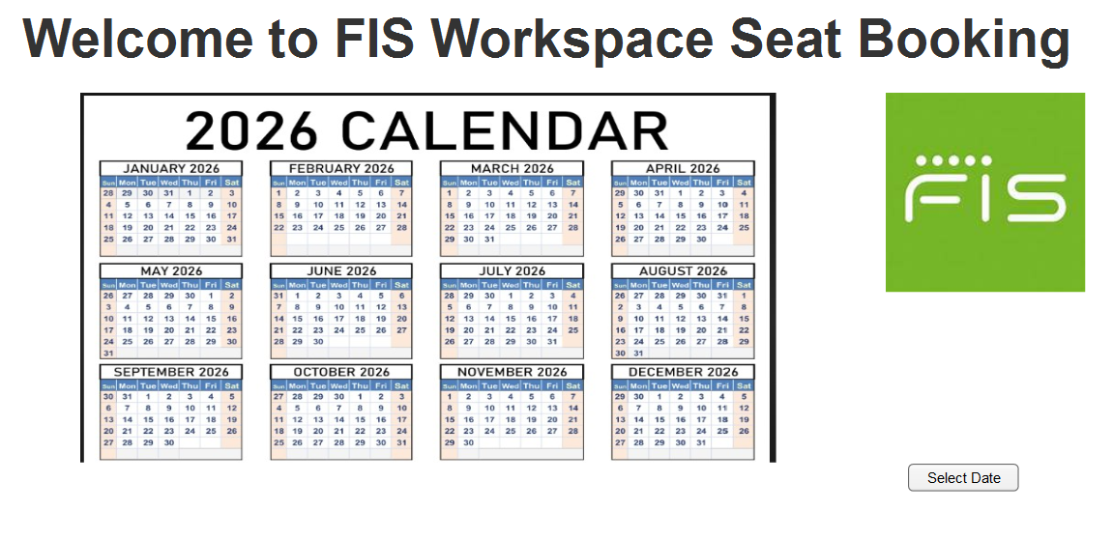

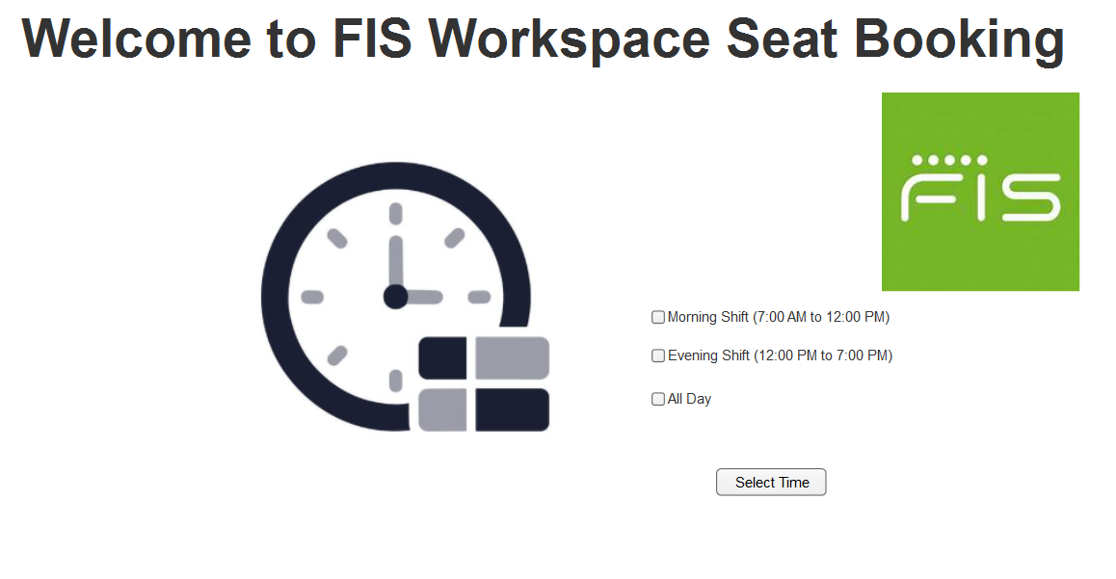

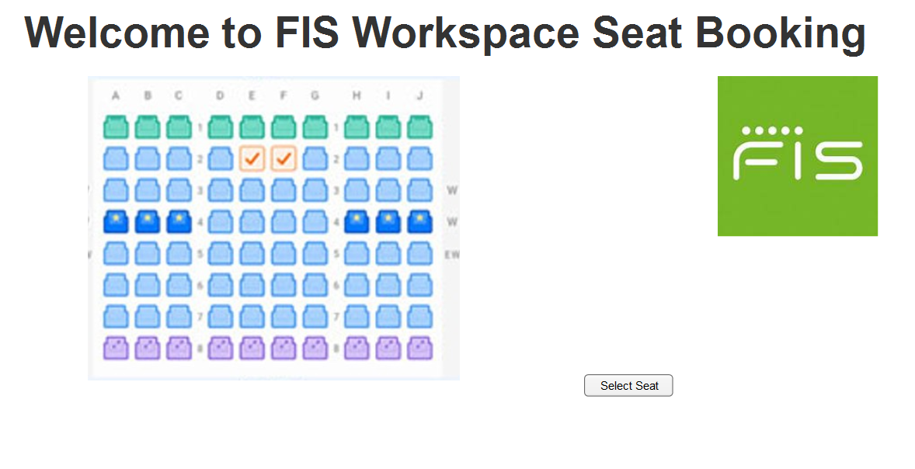

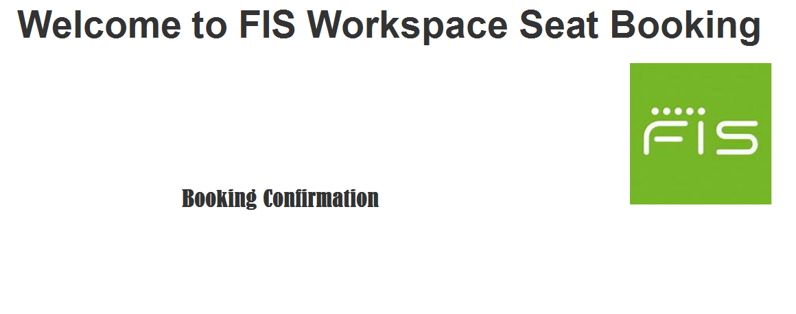

Document 8- Tools-Visio and Axure
Write a paragraph on your experience using Visio and Axure for the project.
I used Visio to draw clear process maps and system diagrams. Visio helped Business Analyst to see how tasks and systems connect. It was easy to change shapes and update flows when requirements changed. Stakeholders understood the diagrams quickly and gave faster feedback.

I used Axure to build interactive wireframes and simple prototypes. Axure let us show how screens behave and how users move through the app. We tested ideas with users and fixed problems before development started. Axure’s annotations made handoffs to developers smoother and reduced confusion.

Document 9- BA experience

My experience as BA in following phases:
- Requirement gathering:
As a Business Analyst, I led the requirement gathering phase.
I used the MOSCOW technique to prioritize requirements: Must, Should, Could, Won’t.
When the client was unavailable, I identified and contacted their points of contact (POC) to get information quickly.
I validated requirements using the FURPS criteria: Functionality, Usability, Reliability, Performance, Supportability.
I found many duplicate or repeated requirements and removed them right away.
I used prototyping to make requirements more specific and easier to understand.

Requirement Analysis:
I created UML diagrams like use case and class diagrams to show the system structure.
I drew activity diagrams to describe each process flow step by step.
I shared these diagrams with the team and stakeholders for review.
When team members disagreed, I listened to their points and updated the diagrams as needed.
I kept diagrams simple and labeled so non-technical stakeholders could understand them.
I wrote the Business Requirements Specification (BRS) to capture high-level business goals and stakeholder needs.
I prepared the System Requirements Specification (SRS) with detailed functional and non-functional requirements.

Design:
From the use case diagrams, I prepared detailed test cases that cover each user action.
I shared the design and solution documents with the client and discussed any feedback until we agreed.
I updated the RTM (Requirements Traceability Matrix) to track each requirement to its test case and design element.

Development:
I organized JAD sessions to align the team on requirements and design.
I clarified technical queries from developers during coding to avoid delays.
When some team members disagreed or did not cooperate, I had one-on-one conversations to understand concerns and explain project impact.
I used the UML and activity diagrams as references for developers to code each unit.
I ran regular meetings with the technical team and the client to track progress and remove blockers.
If someone missed a meeting, I recorded the session and shared the recording, then followed up with a one-on-one discussion.
I tracked action items from meetings and updated project documents so nothing was missed.
I coordinated with QA to ensure code met requirements and supported early testing.
I kept communication calm and constructive to maintain a healthy team environment and steady progress.

Testing:
I wrote both positive and negative test cases to check correct behaviour and error handling.
I made sure not to miss any test case because missing one can cause big problems later.
I prepared test data that matches real scenarios so testing is realistic.
From the use cases, I prepared detailed test cases that cover every user action and system response.
Requested test data from the client to ensure test scenarios reflect real-world conditions.
I collected client signoff on test results and on the updated RTM to confirm requirements are met.
I prepared the client for UAT by sharing test plans, test cases, and step-by-step execution guides.
I scheduled UAT sessions, provided test data and access details, and explained how to log issues.
I recorded UAT outcomes, tracked defects, and coordinated fixes with the development team until the client approved closure.

Deployment:
I forwarded the RTM to the client and asked them to attach it to the project closure document.
I coordinated with the documentation team to complete and share the end user manuals.
I planned and organized training sessions for end users and support staff.
I prepared training materials, slide decks, and step-by-step guides.
I scheduled sessions at times convenient for the client and sent calendar invites.
I made sure all required participants attended the meetings.
When someone could not join, I recorded the session and shared the recording and materials.
I collected training attendance and acknowledgement from participants.
I arranged a short Q&A and hands-on practice during each session to confirm understanding.
I coordinated the final handover with operations and support teams.
I obtained client signoff on deployment and closure documents to formally close the project.

7. Maintenance
Monitored system performance and stability after deployment.
Logged incidents and defects, prioritized fixes based on severity and business impact.
Coordinated with developers and support teams to resolve issues quickly.
Captured enhancement requests and new requirements from stakeholders.
Conducted impact analysis (cost, timeline, compliance) before approving changes.
Updated requirement documents, RTM, and project logs to reflect approved changes.
Gathered feedback from end users through surveys, review meetings, and support tickets.
Proposed usability and performance improvements based on feedback and KPI analysis.
Maintained version control for all documentation.

